Wavelet correlation and coherence: USDJPY and EURGBP
Method 22 / daily log returns / Morlet CWT / Alpari D1 full available history

Study setup
Logical pair: USDJPY , EURGBP
Broker symbols: USDJPY_i , EURGBP_i
Snapshot: 2026-11-03_majors_alpari_D1
Timeframe: D1
Matched return window: 1999-01-06 to 2026-11-02 (UTC bar dates)
Matched return count n: 7181
Dropped unfinished last bar dated 2026-11-03 UTC after a tick-volume check against the prior complete day.
Wavelet: morl; center freq=0.8125; periods=[5, 21, 63]
Headline: rho_wavelet at 21 trading days
Complete matched rows (Excel): USDJPY-EURGBP_Wavelet_D1.xlsx
Complete matched rows (HTML table): USDJPY-EURGBP_Wavelet_D1_data.html

Method carried forward
Wavelet correlation rho_wavelet(s) and local coherence R^2(s,t) measure scale-localized linkage of matched daily log returns of close, ln(close_t / close_t-1). Quotes are not inverted. Continuous wavelet transform uses PyWavelets Morlet ('morl') with center frequency 0.8125; scale = 0.8125 * period_days for pre-specified periods {5, 21, 63}. rho_wavelet is Pearson correlation of demeaned real coefficients at that scale. R^2(s,t) uses a Gaussian smoother in time only (sigma = max(period/4, 2)); mean R^2 drops points within one scale of each edge (cone of influence). Headline is signed rho_wavelet at 21 days. Same-sample Pearson r is a side check only. This is not causation and not a trading signal.

Results (headline)
rho_wavelet 21d: -0.180665
mean R^2 21d: 0.457748
rho_wavelet 5d: -0.129025
mean R^2 5d: 0.350084
rho_wavelet 63d: -0.115098
mean R^2 63d: 0.415808
Pearson r: -0.127992

Scale summary
period_days | scale | rho_wavelet | mean_r2
5 | 4.0625 | -0.12902507 | 0.35008417
21 | 17.0625 | -0.18066495 | 0.45774794
63 | 51.1875 | -0.1150982 | 0.41580785

Conclusion
Headline rho_wavelet at 21d for USDJPY and EURGBP: -0.1807 (mean R^2=0.4577). At 5d: rho=-0.1290, mean R^2=0.3501. At 63d: rho=-0.1151, mean R^2=0.4158. Pearson r = -0.1280. This is scale-localized linkage, not a trading signal.

Charts
Daily closes

Daily log returns

Wavelet correlation by period
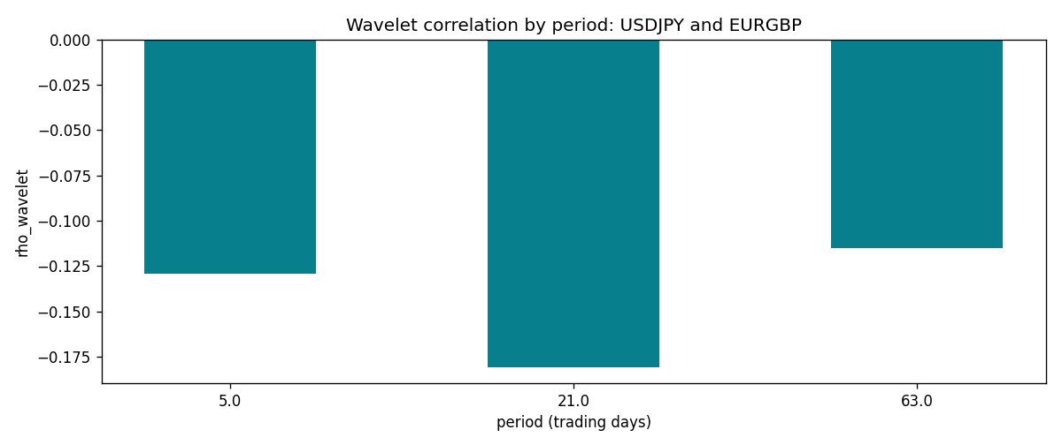

Data report
Matched rows and the scale sheet are in the sibling Excel workbook named USDJPY-EURGBP_Wavelet_D1.xlsx. Embedding all rows as a Word table is impractical; this file holds column summaries and the first and last 15 matched rows.
Columns: time, USDJPY_open, EURGBP_open, USDJPY_high, EURGBP_high, USDJPY_low, EURGBP_low, USDJPY_close, EURGBP_close, USDJPY_tick_volume, EURGBP_tick_volume, USDJPY_spread, EURGBP_spread, USDJPY_real_volume, EURGBP_real_volume, USDJPY_log_return, EURGBP_log_return
Column summaries (matched calculation rows)
column | count | mean | std | min | 25% | 50% | 75% | max
USDJPY_open | 7181 | 113.80773 | 19.228846 | 75.693 | 104.38 | 110.98 | 120.71 | 163.824
EURGBP_open | 7181 | 0.78701429 | 0.09663819 | 0.5734 | 0.6877 | 0.83392 | 0.86523 | 0.9769
USDJPY_high | 7181 | 114.30513 | 19.290536 | 76.001 | 104.865 | 111.439 | 121.27 | 163.978
EURGBP_high | 7181 | 0.79009197 | 0.09701345 | 0.5789 | 0.6897 | 0.83701 | 0.8681 | 0.9799
USDJPY_low | 7181 | 113.28458 | 19.156841 | 75.402 | 103.87 | 110.53 | 120.172 | 163.628
EURGBP_low | 7181 | 0.78431381 | 0.09645598 | 0.5682 | 0.6857 | 0.83166 | 0.86287 | 0.9661
USDJPY_close | 7181 | 113.82069 | 19.244339 | 75.811 | 104.38 | 111.015 | 120.695 | 163.851
EURGBP_close | 7181 | 0.78705735 | 0.09663932 | 0.5735 | 0.6878 | 0.83401 | 0.86539 | 0.977
USDJPY_tick_volume | 7181 | 106398.86 | 179473.16 | 149 | 9958 | 53207 | 92916 | 1803508
EURGBP_tick_volume | 7181 | 87156.048 | 145513.65 | 154 | 6593 | 44384 | 81451 | 1424684
USDJPY_spread | 7181 | 20.250104 | 17.60648 | 0 | 6 | 11 | 30 | 50
EURGBP_spread | 7181 | 21.316669 | 19.115948 | 0 | 4 | 13 | 40 | 50
USDJPY_real_volume | 7181 | 3.4800425e+10 | 1.6097887e+11 | 0 | 0 | 0 | 0 | 3.8834203e+12
EURGBP_real_volume | 7181 | 2.788005e+10 | 1.3523257e+11 | 0 | 0 | 0 | 0 | 3.5726265e+12
USDJPY_log_return | 7181 | 4.847e-05 | 0.00620794 | -0.03908203 | -0.00320533 | 0.00011473 | 0.00340924 | 0.05184024
EURGBP_log_return | 7181 | 2.133e-05 | 0.00487349 | -0.03067367 | -0.00262366 | -0.00010035 | 0.00255918 | 0.06075387
First 15 matched rows (selected columns)
time | USDJPY_log_return | EURGBP_log_return
1999-01-06 | 0.0075660159 | -0.013303338
1999-01-07 | -0.012851583 | 0.011051402
1999-01-08 | -0.0047719894 | -0.004943862
1999-01-11 | -0.016195423 | -0.0012752393
1999-01-12 | 0.032310364 | 0.0033970309
1999-01-13 | 0.0081373171 | 0.00042381861
1999-01-14 | 0 | -0.0019793588
1999-01-15 | 0.0055343401 | -0.0076715819
1999-01-18 | 8.7600193e-05 | 0.00071280921
1999-01-19 | -0.0056219403 | -0.0014261269
1999-01-20 | -0.0053879917 | 0.0019960086
1999-01-21 | 0.0084664056 | -0.00071240297
1999-01-22 | 0.0060412564 | -0.0017118406
1999-01-25 | -0.0073594164 | -0.0054402425
1999-01-26 | 0.0012303367 | -0.00057438255
Last 15 matched rows (selected columns)
time | USDJPY_log_return | EURGBP_log_return
2026-10-13 | -0.0018932826 | 0.00020130374
2026-10-14 | 7.5800166e-05 | 0.0011241873
2026-10-15 | -0.0018524319 | -0.00087557391
2026-10-16 | -0.00037976126 | -0.0020380844
2026-10-19 | 0.0034946841 | -0.00056950988
2026-10-20 | -0.0022546642 | -0.0035906254
2026-10-21 | -0.00032883504 | -0.00140647
2026-10-22 | -0.0085942669 | -0.0018743924
2026-10-23 | 0.00035080446 | 0.00082421033
2026-10-26 | 0.0041238746 | 0.00013133309
2026-10-27 | 0.0027651658 | -0.0019957343
2026-10-28 | -0.00095679538 | 0.00066967224
2026-10-29 | -0.00038043789 | -0.0011722209
2026-10-30 | -0.0010596481 | -0.0024205543
2026-11-02 | 0.0026438521 | 0.00089940465

